Travel MarT Guide

Crew Administrator

July/2014 For Internal Distribution Only
Contents
Introduction 2
How to log-in 3
How to change your password 4
Understanding your Homepage 5
View data by Date 6
Export Manifest 6
Advance search function 7
Understand Vehicle Status 7
Download and Print Itinerary 8
Transportation Information 9
Request transportation for sign offs 9
Edit Transportation 11
How to search through the crew manifest 12
How to view crewmember information 13

Introduction

Last updated: July, 2014
Created by: Chiara van der Kwast

Travel Mart is a web based system created and managed by the Shipboard HR Strategy and Services of Royal Caribbean Cruises Ltd. This tool was designed to provide crewmember travel arrangements.
General information such as; E1identifications, names, and passport information will be visible to all users. Other information including; scheduled bookings with transportation vendors, hotel specialists, and the air team is displayed.
Save and print documents or itineraries, follow ongoing procedures by viewing remarks made by users and much more with Travel Mart.
For support or issues with the system, contact SHRSS_Support@rccl.com

How to log-in

Step 1: Go to Https://www.rclcrew.com
Step 2: Enter your Username and Password in the appropriate fields.
Step 3: Click on Log In
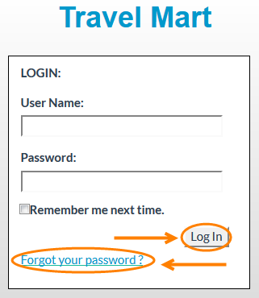
Note: If you are logging in for the first time, enter the username and password provided. Once you have logged in you will be prompted to change your password.
Forgot your password? Click on Forgot your password.
Enter your Username and you will receive and email with your password.
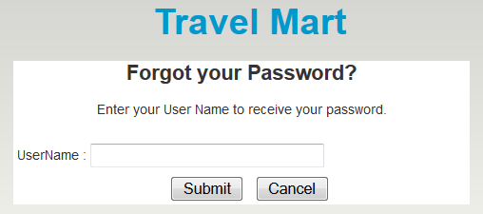

How to change your password

Step 1: At the top right corner of the screen, click on Change Password.
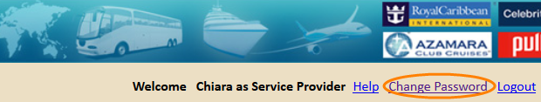
Step 2: In the field Password, enter your current password.
Step 3: In the field New password, enter the new password.
Step 4: Confirm your new password and click on Save.
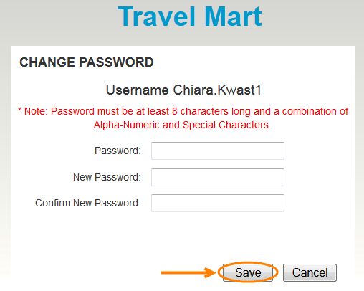

Note: Passwords are case sensitive and must be at least 8 characters long and a combination of Alpha-Numeric and Special Characters.

Understanding your Homepage

When you sign in, the system will recognize your current ship location. The homepage will only display information for crewmembers assigned to user’s current ship.
The details provided include: E1 ID, Last name, First name, AirSeqNo, Vehicle Co., Vehicle Status, Route From and To, Pickup Date, Hotel, Check-In, Check-Out, Hotel Nights, Ship, Room Type, Rank, Gender, Cost Center, Nationality, Meal Allowance, Record Locator, Departure Date, Arrival Date, From and To City, Departure Time, Arrival Time, Airline, Flight number, Status, Port, Passport Number, Date Issued, Passport Expiry, Birthdate, Meet & Greet, Service Provider, Hotel Vendor, Remarks, and Confirmed by and Date.
Step 1: To view all of the information provided to you, scroll back and forth.
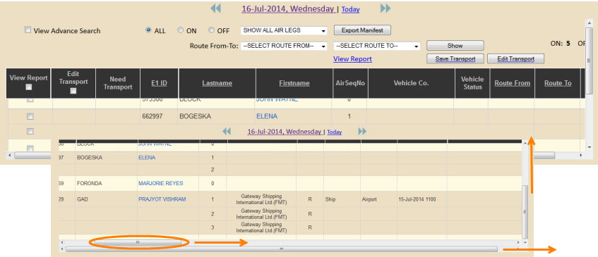
Note: The system will default to the current date. Refer to View data by Date, if you wish to view other than today’s data.
Step 2: Filter information by selecting a status: All, On or Off. Select an air segment through the drop down list to show the necessary air leg.
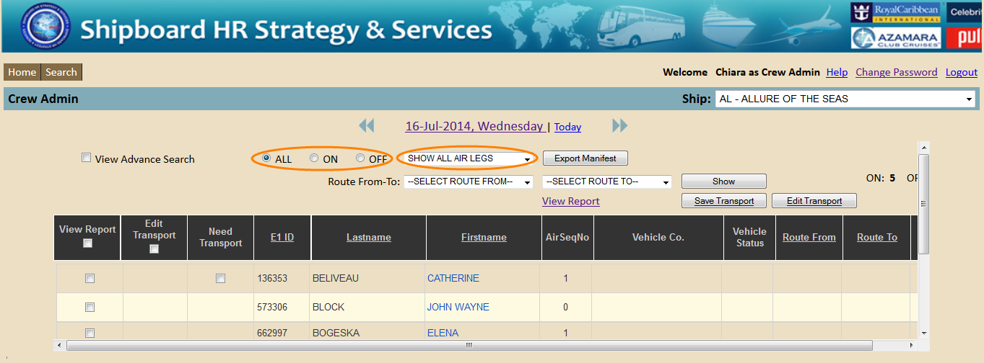

View data by Date

Step 1: Click on the date displayed at the top of the page. A calendar will appear. Or click on the arrows to go back and forth.
Step 2: Select the date you wish to view. A new screen will display details of sign on and off crewmembers for that selected day.
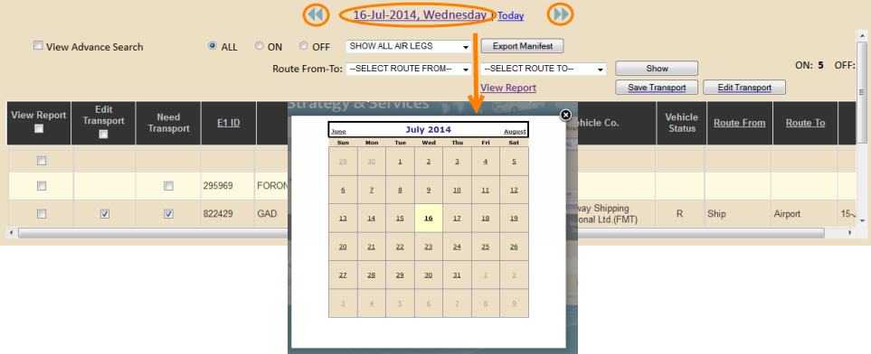

Export Manifest

Step 1: Once you have selected the date required, click on Export Manifest.
Step 2: Save the file as an XML file by clicking OK in the window that appears. Retrieve document in the download file.
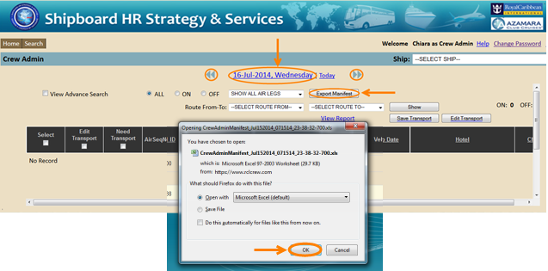

Advance search function

The advanced search option allows you to filter the information on your Homepage.
Step 1: Once you have selected the date required, click on the box next to View Advanced Search. The screen below will appear one the right side of the table. Scroll to the right.
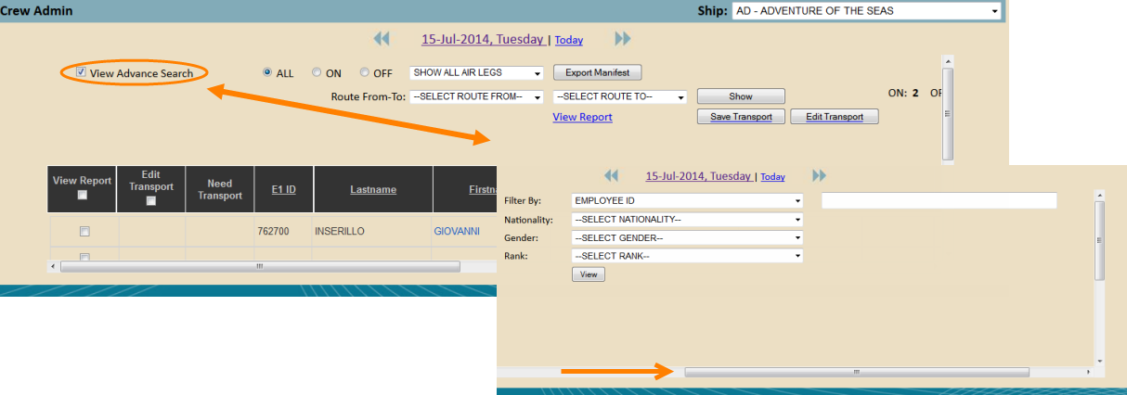
Step 2: Enter the employee ID or select from the drop-down menus to narrow your search.
Step 3: Click on View.
Note: To close this function, uncheck the box next to View Advanced Search.

Understand Vehicle Status

R refers to Requested. The request was auto booked and vendor can see the request.
C refers to Confirmed. The vendor has confirmed the transportation request.

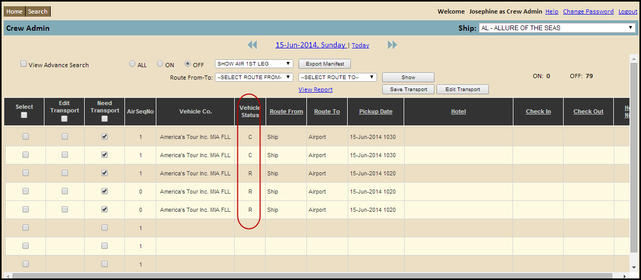

Download and Print Itinerary
Step 1: Download itinerary by selecting the View Report box at the left of the table.

Step 2: Click View Report on top.

Step 3: Click OK in the window that appears and the report will download on to your device as a PDF File. Retrieve document in the download file on your device.

Note: Make sure you have PDF reader installed on your device. If not, visit http://www.adobe.com/products/reader.html to download PDF reader.

You will have the option of Printing, Downloading and Mailing this document by clicking on the icons on the top left of the PDF File.

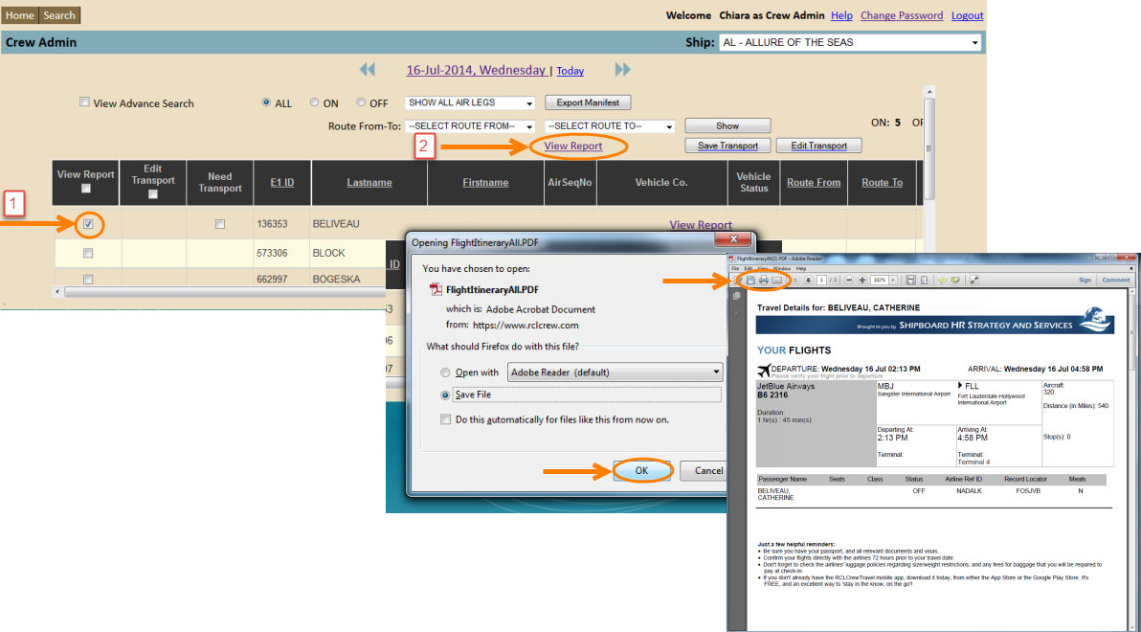

Transportation Information

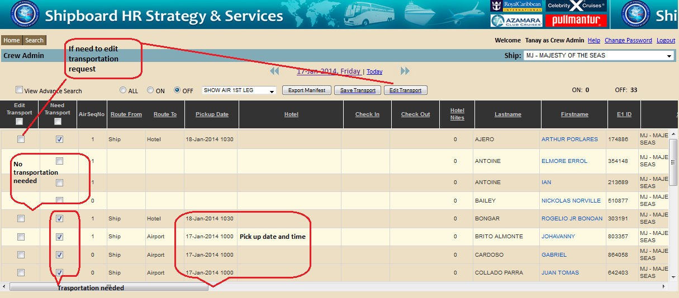

Request transportation for sign offs
Step 1: Select the Need Transport box if transportation is needed, un-check Need Transport box if transportation is not needed.
Note: The Pickup Date will appear if Need Transport boxes are already checked.
Step 2: Click on Save Transport.
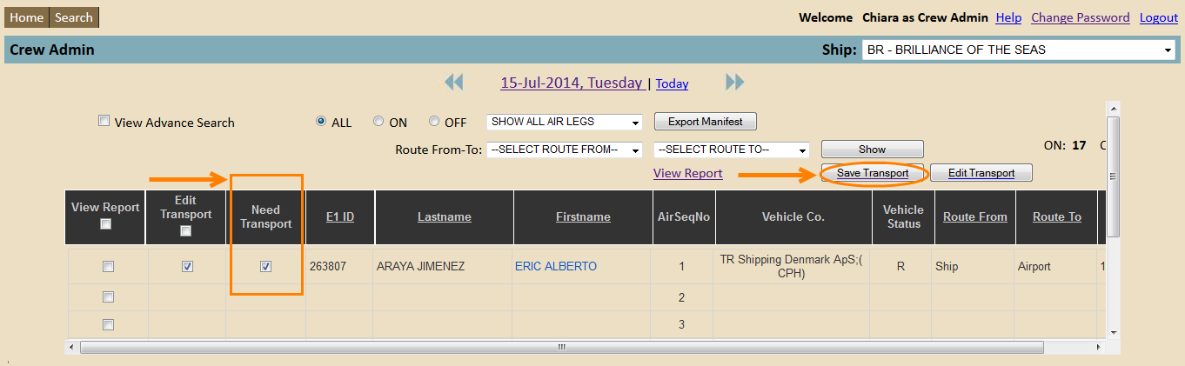
Note: The following window will appear.

Step 3: Add Pickup Time and Pickup Date.
Step 4: Add a Comment for the transport company if necessary.
Step 5: Click on Book/Cancel Transportation and Email to send your transportation request to the vendor.
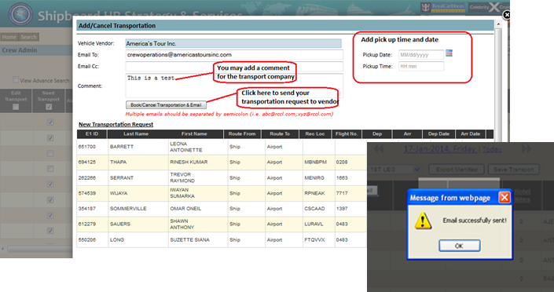
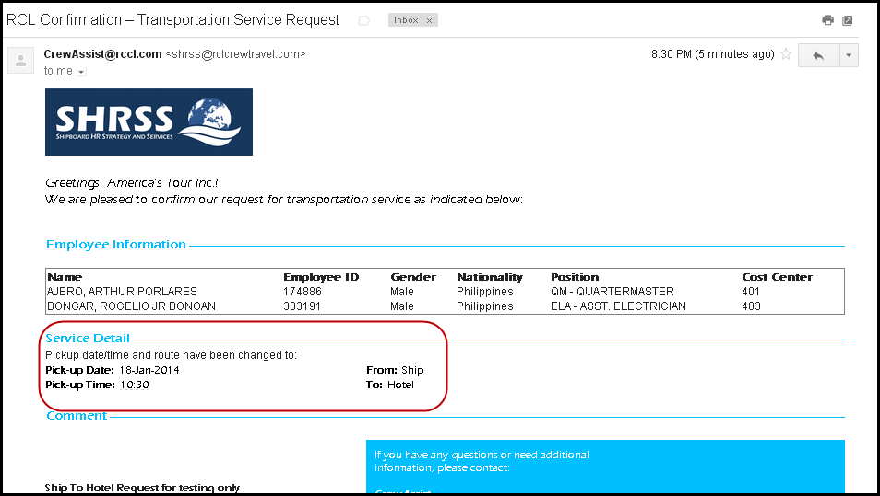
Note: Your email has successfully been sent. The following is the email request that the transportation vendor will receive.

Edit Transportation
Step 1: Select which transportation you wish to edit by checking the Edit Transport boxes on the left side of the table.
Step 2: Click on Edit Transport at the top of the table.
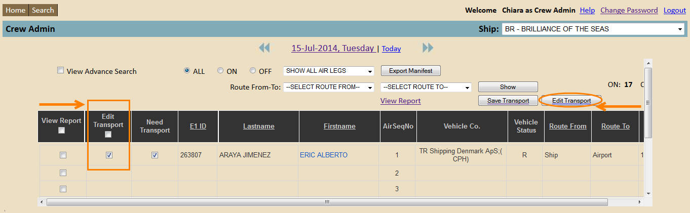
Note: A window will appear with more detailed information on the transportation request.
Step 3: Edit information and click on Save Transportation.
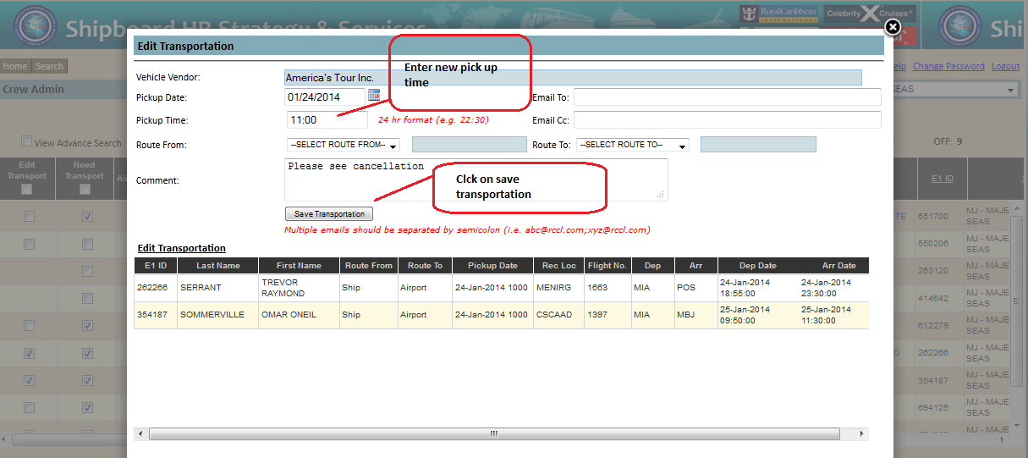

How to search through the crew manifest

To search through the entire crew manifest, follow these steps:
Step 1: On your homepage, click on the Search button in the top left. The Manifest Search Filter will display.
Step 2: Filter crewmember by entering the Employee ID, Last Name, First Name, and/or Record Locator. You can also filter by ship. Enter Code and/or Name of ship.
Step 3: Click on Search.
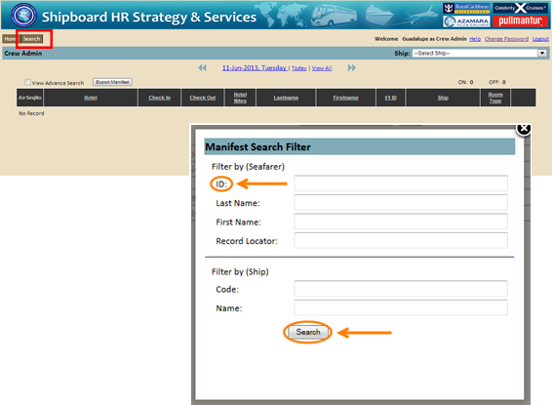
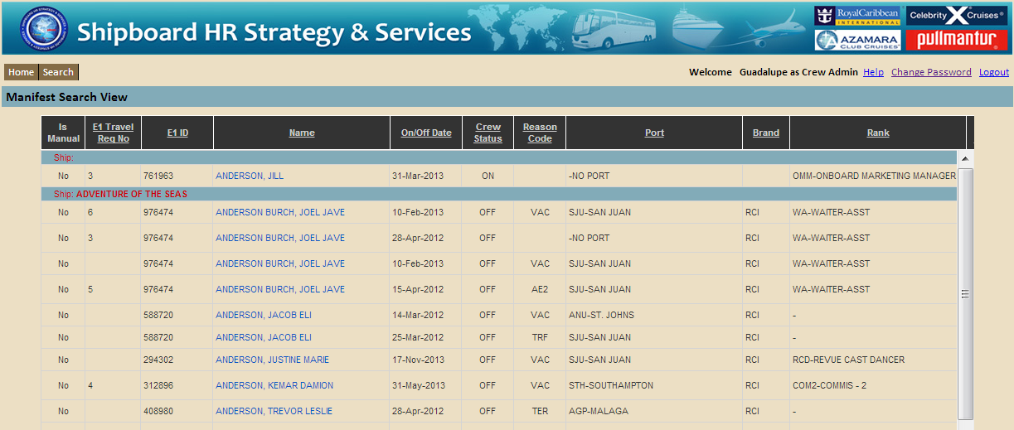
Note: Filtering by Employee ID would be the easiest way to find the correct data seeing as names can have similarities.

How to view crewmember information

Once you have found the correct data you can start reviewing the information visible to you.
On the first page you will be able to view future travel arrangements of the crewmember.
- Scroll back and forth to view all the information provided to you. The information that will be displayed is as follows; E1 Travel number, E1 ID, Name, On/Off Date, Crew Status, Reason Code, Port, Brand, Rank, Air Status, Vehicle Status, Hotel Status, Record Locator, Origin-Destination, Meet & Greet, Service Provider, Hotel vender, and Remarks.

Air, Vehicle, and Hotel status refers to if this service has been scheduled for this specific crewmember.
This sign indicates that this service has not been scheduled for this specific crewmember.
This sign indicates that this service has been scheduled for this specific crewmember.
- Select the View All box on the top left of the page to view past travel arrangements. The travel history will be shown in alphabetical order by ship not by date.

- Click on crewmember name (appears in blue). You will be redirected to a page with more detailed information about the crewmember and travel arrangements.
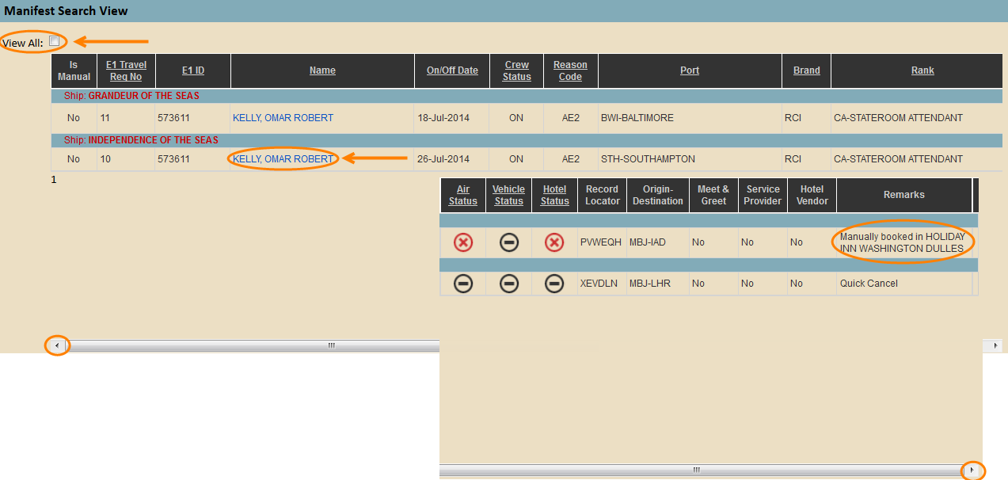
Note: Remarks displayed on the right side of the column are automatically plugged in when changes are made.

In box 1 you will be able to view: E1 ID, Name, Nationality, Gender, Brand, Ship, Rank, Reason Code, Status, Signing ON Date, Signing OFF Date, and Origin/destination.
In box 2 you will be able to posts a remark. See the following steps for further detail.
All other information is as follows: Air Travel, Vehicle, and Port information.
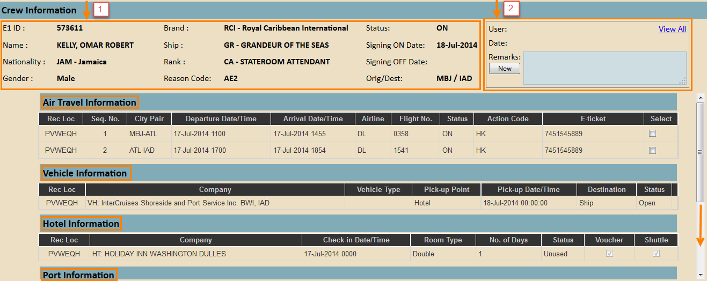

- Post a remark regarding a travel related situation by clicking on New in the comment box on the top right.
- Enter in comment and click on Save or Cancel.
- Click on View All if you wish to view previous remarks made by Crew Assist, the Finance Team and/or Crew Admin.
